**Lab 4 -- Hunting queries and Watchlists**

Objective

Our security researchers shared the following article describing techniques used in the SolarWinds supply chain: [Identifying UNC2452-Related Techniques for ATT&CK](https://medium.com/mitre-attack/identifying-unc2452-related-techniques-9f7b6c7f3714)

Based on the article, our SOC leads understand that to be able to see the full picture of the attack campaign and spot anomalies on our data set, we need to run a proactive threat hunt based on the MITRE tactics and techniques described in this article.

Review the above article that highlights MITRE attack techniques and the corresponding tools and methods. In this exercise, we will focus on T1098. To get a greater understanding of this technique, review this article: <https://attack.mitre.org/techniques/T1098/>

Prerequisites

This Lab assumes that you have completed Lab 1, as the data and the artifacts that we will be using in this Lab need to be deployed on your Microsoft Sentinel instance.

Exercise 1 -- Overview of Hunting queries and Watchlist

Task 1 - Hunting on a specific MITRE technique

1. On the Azure Portal [**http://portal.azure.com**](urn:gd:lg:a:send-vm-keys), search for [**Microsoft Sentinel**](urn:gd:lg:a:send-vm-keys) and click on **Microsoft Sentinel**.

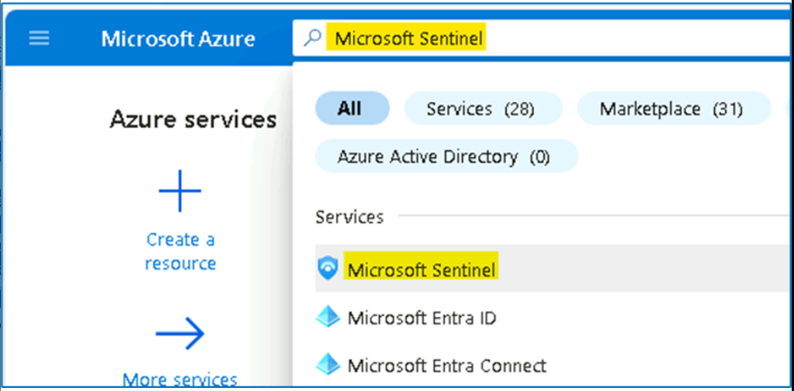

1. Select **SwrkXXXXXXX**.

1. Now click on **Hunting** and then select the **Queries** tab.

1. In the hunting page, we can see that **Microsoft Sentinel** provides built-in **hunting queries** to kick start the proactive hunting process.

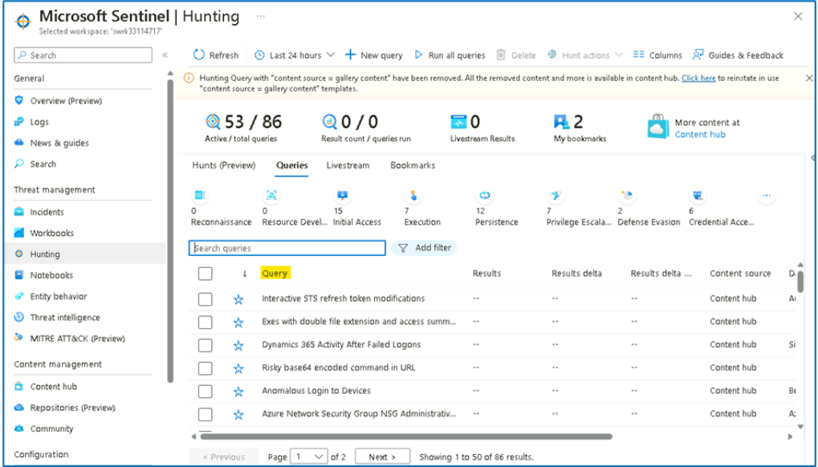

1. On the metric bar we can see statistics about how many queries are "**active**" and have the required data sources to run in your environment. There are also metrics showing how many **queries have been run** in during your current session, and how many of these **queries produced results**. We also see counts of the number of **Livestream results** and **bookmarks** created during the hunting process.

1. On the top action bar, shown in the above diagram, we can find the **Run All queries** button. Clicking on this button runs all active queries. This can take a significant amount of time depending on the number of queries and amount of log data being queried. To get results faster, it helps to **filter** down the set of queries to the specific set you need to run.

1. Microsoft Sentinel provides many different attributes to filter down to just the queries you want to run. To filter by **MITRE technique**, click **Add filter**, select **Techniques.**

1. In the **Techniques** value field, only select **T1098 --** **Account Manipulation** and click **Apply**.

1. Review all the queries in the table using this technique. In this phase we can multi-select all of queries run them as a batch. To do so, press on the multi-select checkboxes for the queries you want to run.
2. Select the filtered queries. Notice that the **Run All Queries** button has changed into the **Run selected queries** button. Click this button to run the queries.

**Note**: In some cases, you will need to modify the selected time range based on the time you deploy the lab to get query results.

1. Once you have **Run selected queries**, the results start popping on the screen. In our case we immediately spot that the **Adding credentials to legitimate OAuth Applications** query returns several results.

1. Select this query and in the right pane press on **View query results**. This will navigate us to the log analytics screen to view the hunting query content and run it.

1. On the **Logs** screen, once the hunting query finishes executing, we can see all the data that returned with the parsed fields and columns. From high overview we can see that we have the actor **IP** and the **username** that run this operation.

1. Expand one of the results and check the fields. As you can see, we are able to spot the Azure AD application name, the added key name and type the IP, username of the actor and other relevant information that help us understand the specific action.

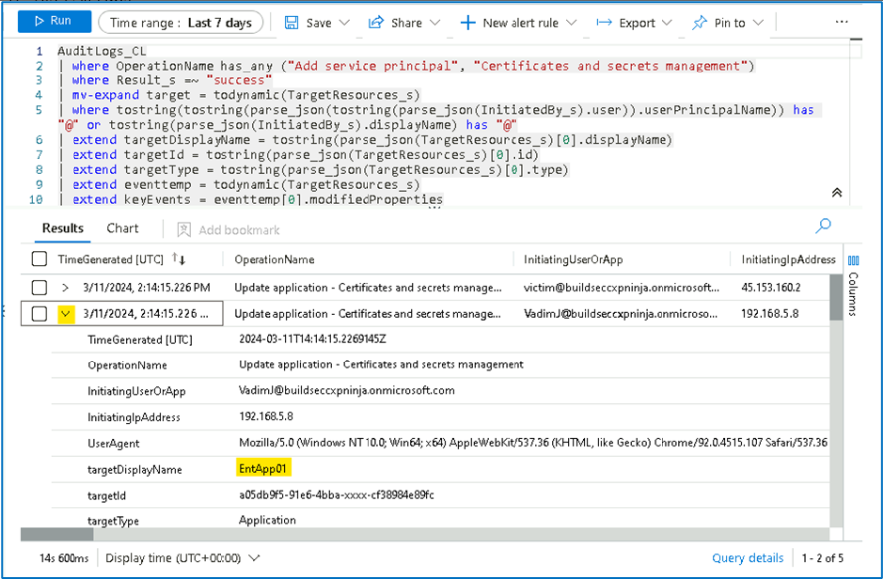

Our SOC analysts needs to know which application from all the above result set is critical and has a security risk. One way to do this is to open Azure Active Directory for each application from the hunting results, check their permissions, and validate the risk. Our SOC analyst follows the organization knowledge base that guides him to review a list for all the AAD applications with their risk levels.

Task 2 - Bookmarking hunting query results

While reviewing query results in Log Analytics, we use Microsoft Sentinel's bookmarking feature to store and enrich these results. We can extract entity identifiers and then use entity pages and the investigation graph to investigate the entity. We can add tags and notes to the results to say why it is interesting. Bookmarks will also preserve the query and time range that generated the specific row result so that analysts can reproduce the query in the future  
If as part of our investigation, we determine that the bookmarked query result contains malicious activity, we can create a new incident from the bookmark, or attach the bookmark to an existing incident.

1. On the **Logs** screen, select the row using the checkbox on the left-hand side of the table. Click **Add bookmark** in the action menu just about the results table.

1. On the right-hand bookmark pane modify the values as following.

* **Bookmark Name** to [**victim@buildseccxpninja.onmicrosoft.com**](mailto:victim@buildseccxpninja.onmicrosoft.com)**added key to purview-spn App with High Risk**.
* Using the drop down in the **entities** section of the **bookmark pane**, map the **Account** entity to the **InitiatingUserOrApp** column.
* Map the **IP entity** to the **InitiatingIpAddress** column.
* We will also add a tag to map it to the main attack story. In the **tags** section write, **"[solorwinds](urn:gd:lg:a:send-vm-keys" \o "Paste text into VM)"**
* Click on **Create** at the bottom of the blade to create the bookmark.

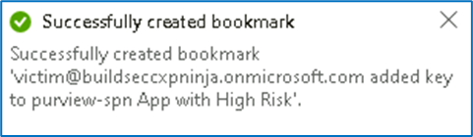

Task 3 - Create a watchlist

This task will show you how to use Microsoft Sentinel watchlists in event correlation and enrichment. Once created, you can use watchlists in your search, detection rules, threat hunting, and response playbooks.

1. On the Azure Portal [**http://portal.azure.com**](urn:gd:lg:a:send-vm-keys), search for [**Microsoft Sentinel**](urn:gd:lg:a:send-vm-keys) and click on **Microsoft Sentinel**.

1. Select **SwrkXXXXXXX**.

1. Now click on **Watchlist** under Configurations, then click on **+** **New**.

1. In the watchlist wizard enter the following and click ***Next: Source***:
   * Name: **[PenTestsIPaddresses](urn:gd:lg:a:send-vm-keys" \o "Paste text into VM)**
   * Description: [**IP addresses used during penetration tests**](urn:gd:lg:a:send-vm-keys)
   * Watchlist Alias: **[PenTestIPaddresses](urn:gd:lg:a:send-vm-keys" \o "Paste text into VM)**

1. In the watchlist wizard, upload the file **C:\Labfiles\Lab4_IPAddresses.csv** from your desktop, under **SearchKey**, select **IPAddress**, review the **File Preview** and click **Next: Review and Create**.

1. On the Review + create tab, click on **Create** to finish the wizard.

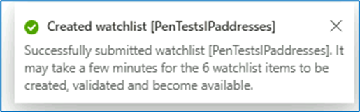

1. You should be back on the **Watchlist** page, click on **Refresh** button to view the newly created watchlist.

1. The watchlist data takes about **3-5 minute** to be available in the workspace. Wait until the **Rows** number changes from 0 to 6. Then click on **View in Log Analytics**. It might take a few minutes to show up.

1. On the Logs details, the Results should appear as shown in below image.

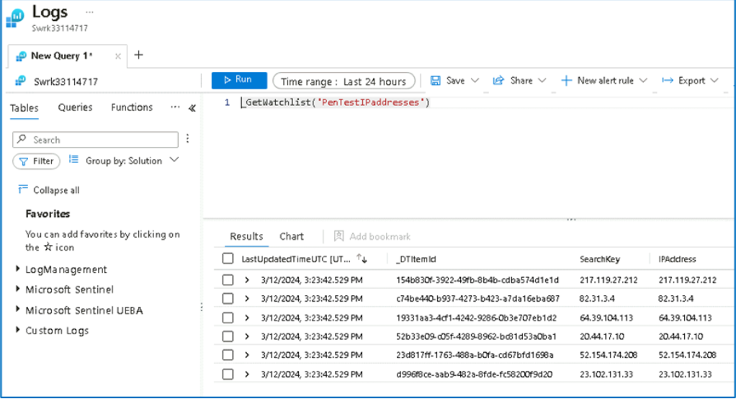

1. We can run the below query to get all the defined watchlists.

[**_GetWatchlistAlias**](urn:gd:lg:a:send-vm-keys)

Congratulations, you have completed Lab 4!